**Paradigm** can also be termed as method to solve some problem or do some task. Programming paradigm is an approach to solve problem using some programming language or also we can say it is a method to solve a problem using tools and techniques that are available to us following some approach.

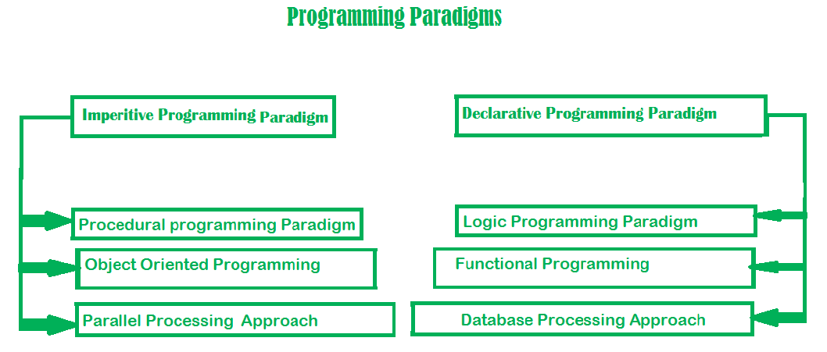

**1. Imperative programming paradigm:** It is one of the oldest programming paradigm. It features close relation to machine architecture. It is based on Von Neumann architecture. It works by changing the program state through assignment statements. It performs step by step task by changing state. The main focus is on how to achieve the goal. The paradigm consist of several statements and after execution of all the result is stored.

**Advantages:**

1. Very simple to implement
2. It contains loops, variables etc.

**Disadvantage:**

1. Complex problem cannot be solved
2. Less efficient and less productive
3. Parallel programming is not possible

Examples of **Imperative** programming paradigm:

**C** : developed by Dennis Ritchie and Ken Thompson

**Fortran** : developed by John Backus for IBM

**Basic** : developed by John G Kemeny and Thomas E Kurtz

* C

|  |
| --- |
| // average of five number in C    int marks[5] = { 12, 32, 45, 13, 19 } int sum = 0;  float average = 0.0;  for (int i = 0; i < 5; i++) {      sum = sum + marks[i];  }  average = sum / 5; |

Imperative programming is divided into three broad categories: Procedural, OOP and parallel processing. These paradigms are as follows:

* **Procedural programming paradigm –**   
  This paradigm emphasizes on procedure in terms of under lying machine model. There is no difference in between procedural and imperative approach. It has the ability to reuse the code and it was boon at that time when it was in use because of its reusability.

Examples of **Procedural** programming paradigm:

**C** : developed by Dennis Ritchie and Ken Thompson

**C++** : developed by Bjarne Stroustrup

**Java** : developed by James Gosling at Sun Microsystems

**ColdFusion** : developed by J J Allaire

**Pascal** : developed by Niklaus Wirth

|  |
| --- |
| #include <iostream>  using namespace std;  int main()  {      int i, fact = 1, num;      cout << "Enter any Number: ";      cin >> number;      for (i = 1; i <= num; i++) {          fact = fact * i;      }      cout << "Factorial of " << num << " is: " << fact << endl;      return 0;  } |

Then comes OOP,

* **Object oriented programming –**   
  The program is written as a collection of classes and object which are meant for communication. The smallest and basic entity is object and all kind of computation is performed on the objects only. More emphasis is on data rather procedure. It can handle almost all kind of real life problems which are today in scenario.

**Advantages:**

* Data security
* Inheritance
* Code reusability
* Flexible and abstraction is also present

Examples of **Object Oriented** programming paradigm:

**Simula** : first OOP language

**Java** : developed by James Gosling at Sun Microsystems

**C++** : developed by Bjarne Stroustrup

**Objective-C** : designed by Brad Cox

**Visual Basic .NET** : developed by Microsoft

**Python** : developed by Guido van Rossum

**Ruby** : developed by Yukihiro Matsumoto

**Smalltalk** : developed by Alan Kay, Dan Ingalls, Adele Goldberg

**Example:**

|  |
| --- |
| import java.io.*;    class GFG {      public static void main(String[] args)      {          System.out.println("GfG!");          Signup s1 = new Signup();          s1.create(22, "riya", "riya2@gmail.com", 'F',                    89002);      }  }    class Signup {      int userid;      String name;      String emailid;      char sex;      long mob;        public void create(int userid, String name,                         String emailid, char sex, long mob)      {          System.out.println(              "Welcome to GeeksforGeeks\nLets create your account\n");          this.userid = 132;          this.name = "Radha";          this.emailid = "radha.89@gmail.com";          this.sex = 'F';          this.mob = 900558981;          System.out.println("your account has been created");      }  } |

**Output**

GfG!

Welcome to GeeksforGeeks

Lets create your account

your account has been created

* **Parallel processing approach –**   
  Parallel processing is the processing of program instructions by dividing them among multiple processors. A parallel processing system posses many numbers of processor with the objective of running a program in less time by dividing them. This approach seems to be like divide and conquer. Examples are NESL (one of the oldest one) and C/C++ also supports because of some library function.

**2. Declarative programming paradigm:**   
It is divided as Logic, Functional, Database. In computer science the *declarative programming* is a style of building programs that expresses logic of computation without talking about its control flow. It often considers programs as theories of some logic.It may simplify writing parallel programs. The focus is on what needs to be done rather how it should be done basically emphasize on what code is actually doing. It just declares the result we want rather how it has be produced. This is the only difference between imperative (how to do) and declarative (what to do) programming paradigms. Getting into deeper we would see logic, functional and database.

* **Logic programming paradigms –**   
  It can be termed as abstract model of computation. It would solve logical problems like puzzles, series etc. In logic programming we have a knowledge base which we know before and along with the question and knowledge base which is given to machine, it produces result. In normal programming languages, such concept of knowledge base is not available but while using the concept of artificial intelligence, machine learning we have some models like Perception model which is using the same mechanism.   
  In logical programming the main emphasize is on knowledge base and the problem. The execution of the program is very much like proof of mathematical statement, e.g., Prolog

predicates

sumoftwonumber(integer, integer).

clauses

sumoftwonumber(0, 0).

sumoftwonumber(N, R) :-

N > 0,

N1 is N - 1,

sumoftwonumber(N1, R1),

R is R1 + N.

* **Functional programming paradigms –**   
  The functional programming paradigms has its roots in mathematics and it is language independent. The key principle of this paradigms is the execution of series of mathematical functions. The central model for the abstraction is the function which are meant for some specific computation and not the data structure. Data are loosely coupled to functions.The function hide their implementation. Function can be replaced with their values without changing the meaning of the program. Some of the languages like perl, javascript mostly uses this paradigm.

Examples of **Functional** programming paradigm:

**JavaScript** : developed by Brendan Eich

**Haskell** : developed by Lennart Augustsson, Dave Barton

**Scala** : developed by Martin Odersky

**Erlang** : developed by Joe Armstrong, Robert Virding

**Lisp** : developed by John Mccarthy

**ML** : developed by Robin Milner

**Clojure** : developed by Rich Hickey

The next kind of approach is of Database.

* **Database/Data driven programming approach –**   
  This programming methodology is based on data and its movement. Program statements are defined by data rather than hard-coding a series of steps. A database program is the heart of a business information system and provides file creation, data entry, update, query and reporting functions. There are several programming languages that are developed mostly for database application. For example SQL. It is applied to streams of structured data, for filtering, transforming, aggregating (such as computing statistics), or calling other programs. So it has its own wide application.

CREATE DATABASE databaseAddress;

CREATE TABLE Addr (

PersonID int,

LastName varchar(200),

FirstName varchar(200),

Address varchar(200),

City varchar(200),

State varchar(200)

);